COVID-19 Supply Order Sheet
Requested by:
Department:
Cost Center:
Delivery Location:
Unit Lead Approval (required):
ITEM | QTY
Hand Sanitizer
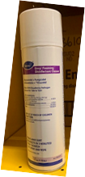Spray Disinfectant "Envy"
Nitrile Gloves - MED
Nitrile Gloves - LG
Nitrile Gloves - XL
Non-FR Balaclava
/ FR-Balaclava: Half Face / FR Surgical Masks
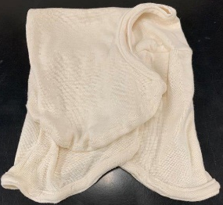 FR-Balaclava: Full Face | OUT OF STOCK
Dust Mask-NOT N95
Bandanas
Not-Industrial Face Shields
Disposable Face Mask
Homemade Masks
Reusable Face Masks

